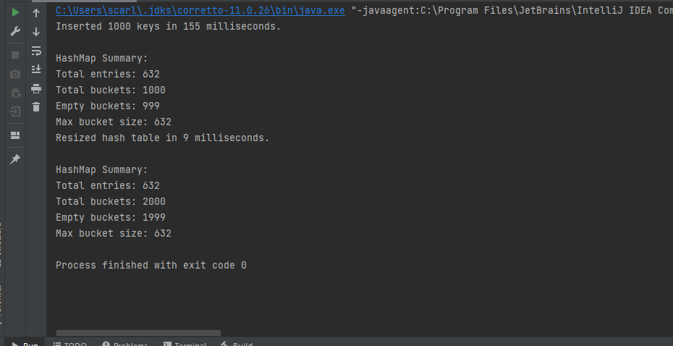

Instead of names I changed it to keys and did about 1000 because 10000 broke my computer and by broke, I mean it wouldn’t output anything. I think it is interesting how quickly the hash table was resized and how quickly the keys were inserted.